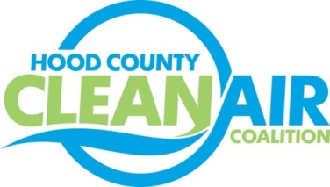
Meeting: Thursday, January 5, 2016
Neely House
304 East Rucker Street, Granbury, Texas 76048
8:30-10:00 a.m.

Agenda

- Call Meeting to Order
- EPA Updates – Randy Pitre
- Regional Updates – Michelle McKenzie
  - DFW Clean Cities Annual Report Data Collection
  - New DFW Clean Cities Website
  - Notice of Public Hearing and Extension of Comment Period: Implementation of the 2015 National Ambient Air Quality Standards for Ozone. Information at https://www.gpo.gov/fdsys/pkg/FR-2016-12-19/html/2016-30365.htm.
  - Feedback Requested
    - Fleet Alternative Fuel Vehicle Obstacles and Procurement Plans Until the End of the Year: https://www.surveymonkey.com/r/FleetsFortheFuture
    - Engines Off North Texas: Input on Regional Priorities on Idle Reduction Initiatives: http://www.nctcog.org/trans/air/programs/idling/engineoffnorthtexas/index.asp
  - Air Quality Funding Opportunities: www.nctcog.org/aqfunding
- Local Updates – Michelle McKenzie
  - Review of December Meeting Summary
  - Review of Projects
    - Monthly Budget Review for November
    - Status of Projects FY 16/17
  - Reports - EPA Webinar: Proposed Implementation Rule
5.) Discussion
6.) Adjourn

